


Informatics Institute of Technology

Client-Server Architectures
5COSC022C.2
Module Leader – Mr. Cassim Farook

Muhammed Saad Mazhar
Uow Number – W20532233
IIT Number – 20221804

Table of Contents
1. Introduction 3
2. API Endpoint Test Case Tables 5
2.1 BookResource Test Cases 5
2.1.1 POST /books Endpoint: 5
2.1.2 GET /books Endpoint: 7
2.1.3 GET /books/{id} Endpoint: 8
2.1.4 PUT /books/{id} Endpoint: 9
2.1.5 DELETE /books/{id} Endpoint: 10
2.2 AuthorResource Test Cases 11
2.2.1 POST /authors Endpoint: 11
2.2.2 GET /authors Endpoint: 12
2.2.3 GET /authors/{id} Endpoint: 13
2.2.4 PUT /authors/{id} Endpoint: 14
2.2.5 DELETE /authors/{id} Endpoint: 15
2.2.6 GET /authors/{id}/books Endpoint: 16
2.3 CustomerResource Test Cases 17
2.3.1 POST /customers Endpoint: 17
2.3.2 GET /customers Endpoint: 18
2.3.3 GET /customers/{id} Endpoint: 19
2.3.4 PUT /customers/{id} Endpoint: 20
2.3.5 DELETE /customers/{id} Endpoint: 21
2.4 CartResource Test Cases 22
2.4.1 GET /customers/{customerId}/cart Endpoint: 22
2.4.2 POST /customers/{customerId}/cart/items Endpoint: 23
2.4.3 PUT /customers/{customerId}/cart/items/{bookId} Endpoint: 25
2.4.4 DELETE /customers/{customerId}/cart/items/{bookId} Endpoint: 26
2.5 OrderResource Test Cases 28
2.5.1 POST /customers/{customerId}/orders Endpoint: 28
2.5.2 GET /customers/{customerId}/orders Endpoint: 30
2.5.3 GET /customers/{customerId}/orders/{orderId} Endpoint: 31

List of tables

Table 1 - POST /books Endpoint 6
Table 2 - GET /books Endpoint 7
Table 3 - GET /books/{id} Endpoint 8
Table 4 - PUT /books/{id} Endpoint 9
Table 5 - DELETE /books/{id} Endpoint 10
Table 6 - POST /authors Endpoint 11
Table 7 - GET /authors Endpoint 12
Table 8 - GET /authors/{id} Endpoint 13
Table 9 - PUT /authors/{id} Endpoint 14
Table 10 - DELETE /authors/{id} Endpoint 15
Table 11 - GET /authors/{id}/books Endpoint 16
Table 12 - POST /customers Endpoint 17
Table 13 - GET /customers Endpoint 18
Table 14 - GET /customers/{id} Endpoint 19
Table 15 - PUT /customers/{id} Endpoint 20
Table 16 - DELETE /customers/{id} Endpoint 21
Table 17 - GET /customers/{customerId}/cart Endpoint 22
Table 18 - POST /customers/{customerId}/cart/items Endpoint 23
Table 19 - PUT /customers/{customerId}/cart/items/{bookId} Endpoint 25
Table 20 - DELETE /customers/{customerId}/cart/items/{bookId} Endpoint 27
Table 21 - POST /customers/{customerId}/orders Endpoint 28
Table 22 - GET /customers/{customerId}/orders Endpoint 30
Table 23 - GET /customers/{customerId}/orders/{orderId} Endpoint 31

Introduction

This report documents the comprehensive testing of the RESTful Bookstore API, developed as part of the Client-Server Architectures coursework at the University of Westminster. The testing focuses on validating the API's functionality, error handling, and adherence to RESTful design principles.
Technology Stack
The API implementation utilizes the following technologies:
- Java 11: Core programming language
- JAX-RS: Java API for RESTful Web Services specification
- Jersey: Implementation framework for JAX-RS
- Maven: Project management and dependency handling
- JSON: Data interchange format for request/response bodies
- Tomcat 9: Servlet container for deployment
Testing Environment
All tests were conducted using Postman v10.13, a specialized API development and testing platform that allows for:
- Creation and organization of HTTP requests
- Setting request parameters, headers, and bodies
- Examination of response status codes and body content
- Verification of error handling capabilities
- Automation of test sequences

2. API Endpoint Test Case Tables

2.1 BookResource Test Cases

2.1.1 POST /books Endpoint:

Endpoint | Description | HTTP Method | Request Body (JSON) | Expected HTTP Status Code | Expected Response Body (JSON) | Actual Result
POST /books | Create a book with valid data | POST | { "title": "The Great Gatsby", "authorId": 1, "isbn": "978-0-7432-7356-5", "publicationYear": 1925, "price": 12.99, "stock": 50 } | 201 Created | { "id": 1, "title": "The Great Gatsby", "authorId": 1, "isbn": "978-0-7432-7356-5", "publicationYear": 1925, "price": 12.99, "stock": 50 } | Pass
POST /books | Create a book with invalid author ID (not found) | POST | { "title": "The Great Gatsby", "authorId": 999, "isbn": "978-0-7432-7356-5", "publicationYear": 1925, "price": 12.99, "stock": 50 } | 404 Not Found | { "error": "Author Not Found", "message": "Author with ID 999 does not exist." } | Pass
POST /books | Create a book with invalid publication year (future) | POST | { "title": "Future Book", "authorId": 1, "isbn": "978-0-1234-5678-9", "publicationYear": 2030, "price": 15.99, "stock": 30 } | 400 Bad Request | { "error": "Invalid Input", "message": "Publication year cannot be in the future." } | Pass
POST /books | Create a book with empty title | POST | { "title": "", "authorId": 1, "isbn": "978-0-1234-5678-9", "publicationYear": 2020, "price": 15.99, "stock": 30 } | 400 Bad Request | { "error": "Invalid Input", "message": "Book title cannot be empty." } | Pass
POST /books | Create a book with negative price | POST | { "title": "Discount Book", "authorId": 1, "isbn": "978-0-1234-5678-9", "publicationYear": 2020, "price": -5.99, "stock": 30 } | 400 Bad Request | { "error": "Invalid Input", "message": "Price must be greater than zero." } | Pass
Table 1 - POST /books Endpoint

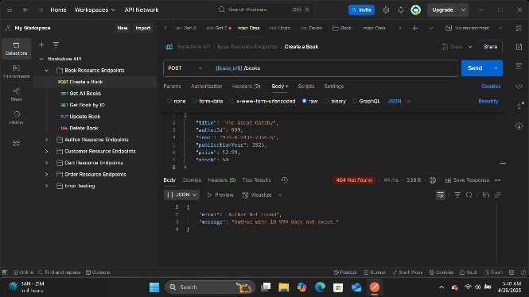
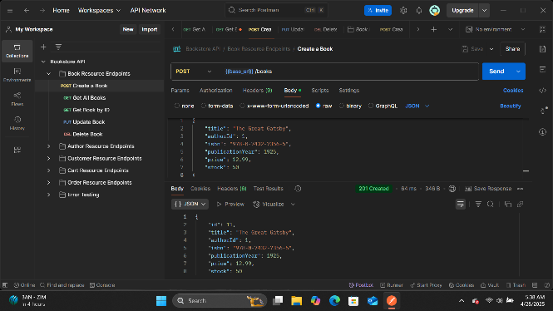
Figure 1 - Create a book with invalid author ID (not found)
Figure 2 - Create a book with valid data

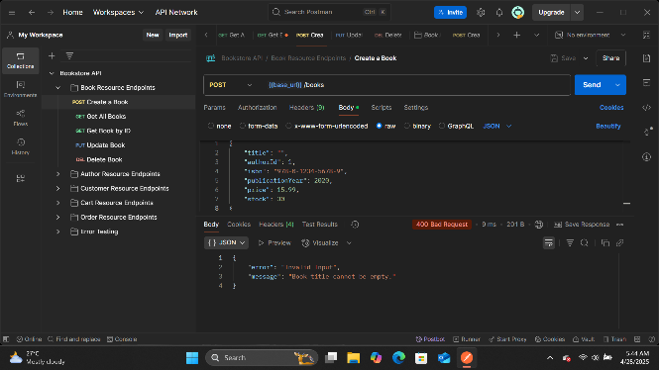
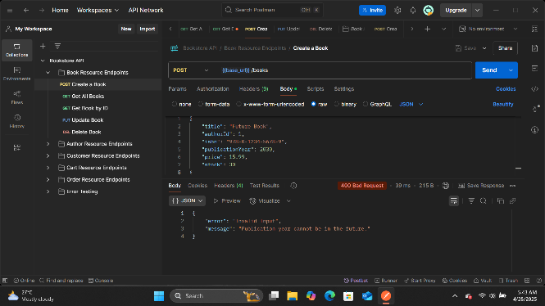
Figure 3 - Create a book with empty title
Figure 4 - Create a book with invalid publication year

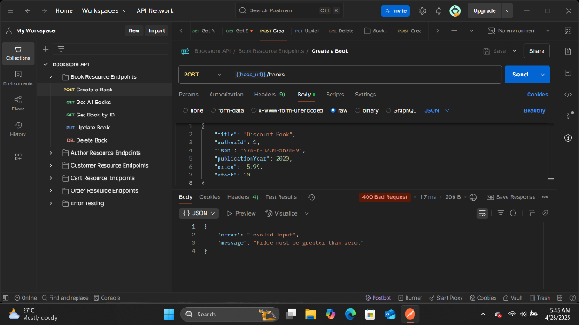
Figure 5 - Create a book with negative price

2.1.2 GET /books Endpoint:

Endpoint | Description | HTTP Method | Request Body (JSON) | Expected HTTP Status Code | Expected Response Body (JSON) | Actual Result
GET /books | Get all books | GET | N/A | 200 OK | [ { "id": 1, "title": "The Great Gatsby", ... }, { "id": 2, "title": "To Kill a Mockingbird", ... } ] | Pass
GET /books | Get all books (empty list) | GET | N/A | 200 OK | [] | Pass
Table 2 - GET /books Endpoint

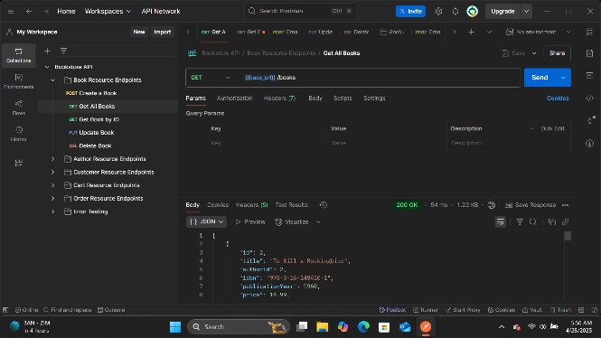
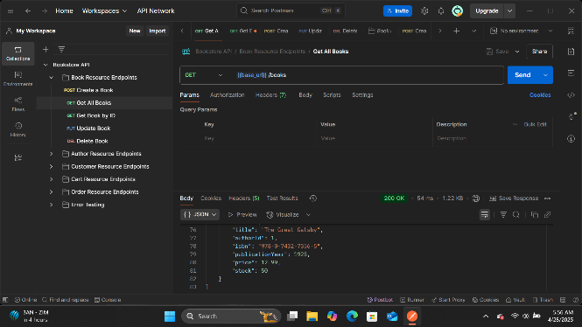
Figure 6 - Get all books (empty list)
Figure 7 - Get all books

2.1.3 GET /books/{id} Endpoint:

Endpoint | Description | HTTP Method | Request Body (JSON) | Expected HTTP Status Code | Expected Response Body (JSON) | Actual Result
GET /books/1 | Get book by valid ID | GET | N/A | 200 OK | { "id": 1, "title": "The Great Gatsby", "authorId": 1, "isbn": "978-0-7432-7356-5", "publicationYear": 1925, "price": 12.99, "stock": 50 } | Pass
GET /books/999 | Get book by invalid ID | GET | N/A | 404 Not Found | { "error": "Book Not Found", "message": "Book with ID 999 does not exist." } | Pass
Table 3 - GET /books/{id} Endpoint

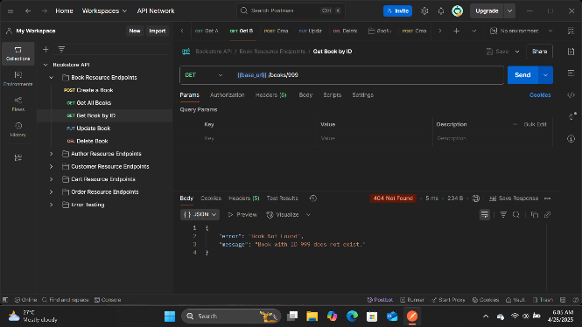
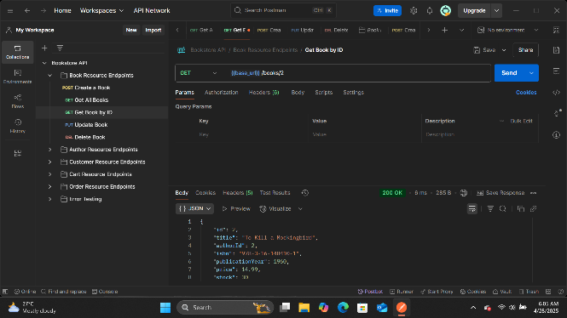
Figure 8 - Get book by invalid ID
Figure 9 - Get book by valid ID

2.1.4 PUT /books/{id} Endpoint:

Endpoint | Description | HTTP Method | Request Body (JSON) | Expected HTTP Status Code | Expected Response Body (JSON) | Actual Result
PUT /books/1 | Update book with valid data | PUT | { "title": "The Great Gatsby (Updated)", "authorId": 1, "isbn": "978-0-7432-7356-5", "publicationYear": 1925, "price": 14.99, "stock": 45 } | 200 OK | { "id": 1, "title": "The Great Gatsby (Updated)", "authorId": 1, "isbn": "978-0-7432-7356-5", "publicationYear": 1925, "price": 14.99, "stock": 45 } | Pass
PUT /books/999 | Update book with non-existent ID | PUT | { "title": "Non-existent Book", "authorId": 1, "isbn": "978-0-1111-2222-3", "publicationYear": 2020, "price": 19.99, "stock": 20 } | 404 Not Found | { "error": "Book Not Found", "message": "Book with ID 999 does not exist." } | Pass
PUT /books/1 | Update book with invalid data (negative stock) | PUT | { "title": "The Great Gatsby", "authorId": 1, "isbn": "978-0-7432-7356-5", "publicationYear": 1925, "price": 14.99, "stock": -10 } | 400 Bad Request | { "error": "Invalid Input", "message": "Stock cannot be negative." } | Pass
Table 4 - PUT /books/{id} Endpoint
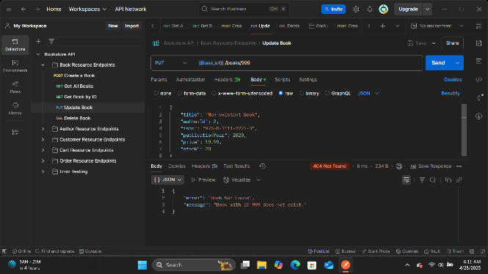
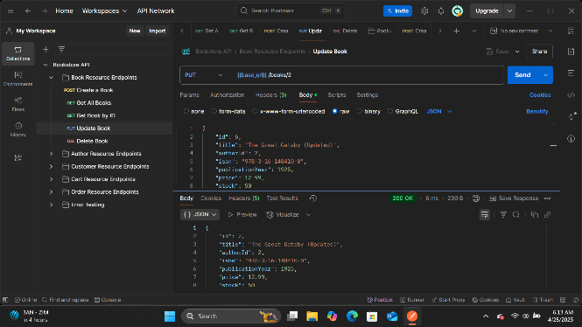
Figure 10 - Update book with non-existent ID
Figure 11 - Update book with valid data

2.1.5 DELETE /books/{id} Endpoint:

Endpoint | Description | HTTP Method | Request Body (JSON) | Expected HTTP Status Code | Expected Response Body (JSON) | Actual Result
DELETE /books/1 | Delete book by valid ID | DELETE | N/A | 204 No Content | N/A | Pass
DELETE /books/999 | Delete book by invalid ID | DELETE | N/A | 404 Not Found | { "error": "Book Not Found", "message": "Book with ID 999 does not exist." } | Pass
Table 5 - DELETE /books/{id} Endpoint
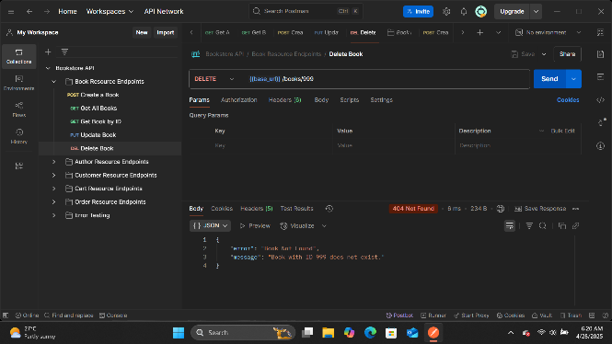
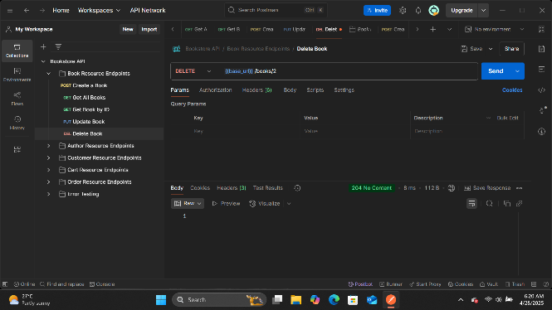
Figure 12 - Delete book by invalid ID
Figure 13 - Delete book by valid ID

2.2 AuthorResource Test Cases

2.2.1 POST /authors Endpoint:

Endpoint | Description | HTTP Method | Request Body (JSON) | Expected HTTP Status Code | Expected Response Body (JSON) | Actual Result
POST /authors | Create an author with valid data | POST | { "name": "F. Scott Fitzgerald", "biography": "American novelist known for The Great Gatsby" } | 201 Created | { "id": 1, "name": "F. Scott Fitzgerald", "biography": "American novelist known for The Great Gatsby" } | Pass
POST /authors | Create an author with empty name | POST | { "name": "", "biography": "Author biography" } | 400 Bad Request | { "error": "Invalid Input", "message": "Author name cannot be empty." } | Pass
Table 6 - POST /authors Endpoint
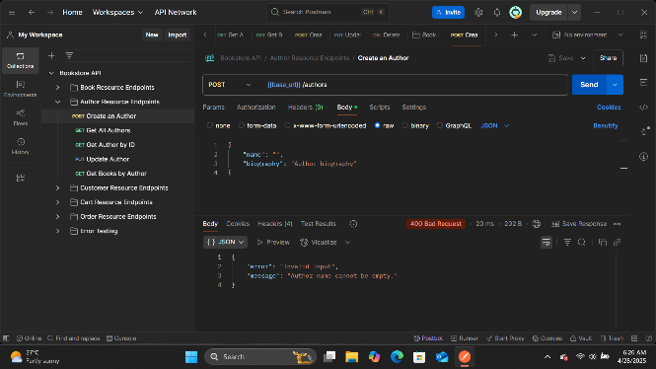
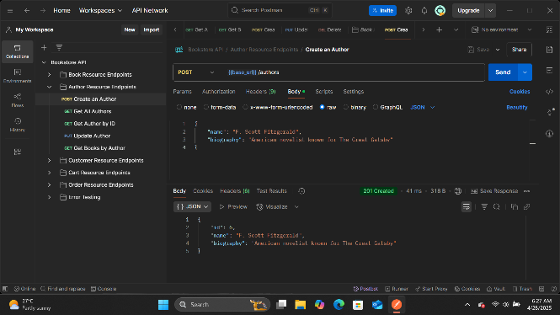

Figure 14 - Create an author with empty name
Figure 15 - Create an author with valid data

2.2.2 GET /authors Endpoint:

Endpoint | Description | HTTP Method | Request Body (JSON) | Expected HTTP Status Code | Expected Response Body (JSON) | Actual Result
GET /authors | Get all authors | GET | N/A | 200 OK | [ { "id": 1, "name": "F. Scott Fitzgerald", ... }, { "id": 2, "name": "Harper Lee", ... } ] | Pass
GET /authors | Get all authors (empty list) | GET | N/A | 200 OK | [] | Pass
Table 7 - GET /authors Endpoint
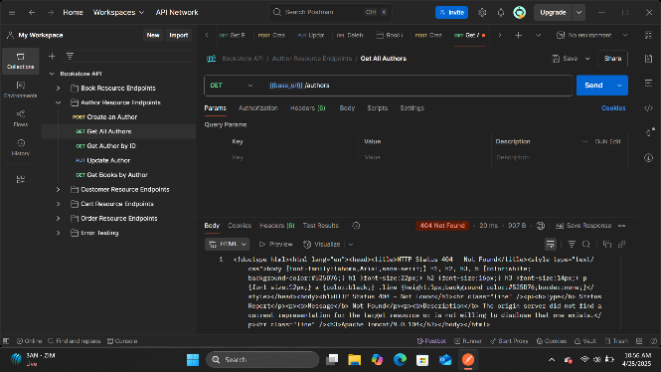
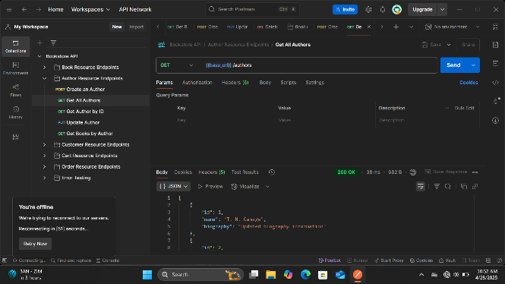
Figure 16 - Get all authors (Empty List)
Figure 17 - Get all authors

2.2.3 GET /authors/{id} Endpoint:

Endpoint | Description | HTTP Method | Request Body (JSON) | Expected HTTP Status Code | Expected Response Body (JSON) | Actual Result
GET /authors/1 | Get author by valid ID | GET | N/A | 200 OK | { "id": 1, "name": "F. Scott Fitzgerald", "biography": "American novelist known for The Great Gatsby" } | Pass
GET /authors/999 | Get author by invalid ID | GET | N/A | 404 Not Found | { "error": "Author Not Found", "message": "Author with ID 999 does not exist." } | Pass
Table 8 - GET /authors/{id} Endpoint
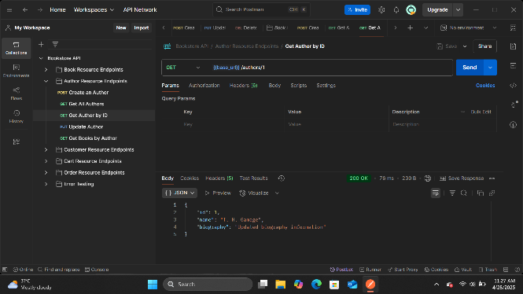
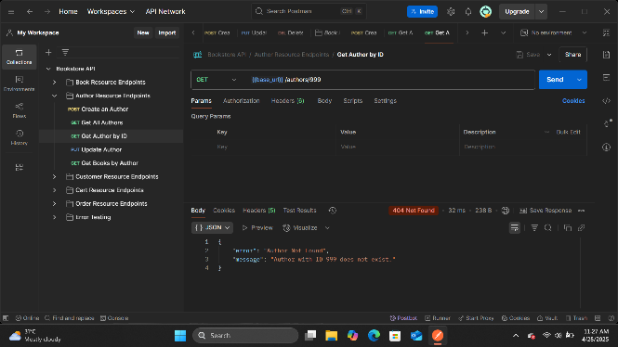
Figure 18 - Get author by valid ID
Figure 19 - Get author by invalid ID

2.2.4 PUT /authors/{id} Endpoint:

Endpoint | Description | HTTP Method | Request Body (JSON) | Expected HTTP Status Code | Expected Response Body (JSON) | Actual Result
PUT /authors/1 | Update author with valid data | PUT | { "name": "F. Scott Fitzgerald", "biography": "Updated biography of the author" } | 200 OK | { "id": 1, "name": "F. Scott Fitzgerald", "biography": "Updated biography of the author" } | Pass
PUT /authors/999 | Update author with non-existent ID | PUT | { "name": "Unknown Author", "biography": "Author does not exist" } | 404 Not Found | { "error": "Author Not Found", "message": "Author with ID 999 does not exist." } | Pass
PUT /authors/1 | Update author with empty name | PUT | { "name": "", "biography": "Biography content" } | 400 Bad Request | { "error": "Invalid Input", "message": "Author name cannot be empty." } | Pass
Table 9 - PUT /authors/{id} Endpoint
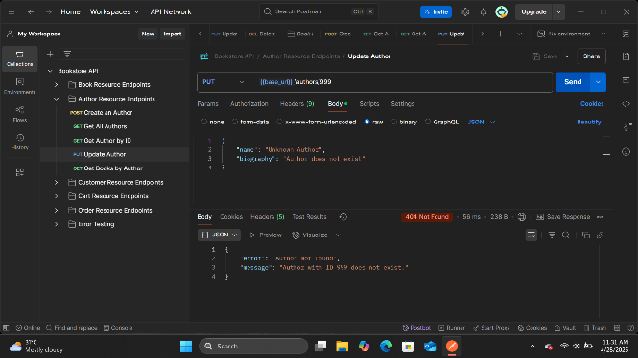
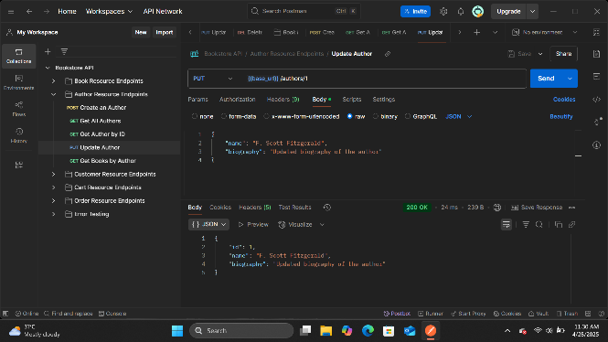
Figure 20 - Update author with non-existent ID
Figure 21 - Update author with valid data

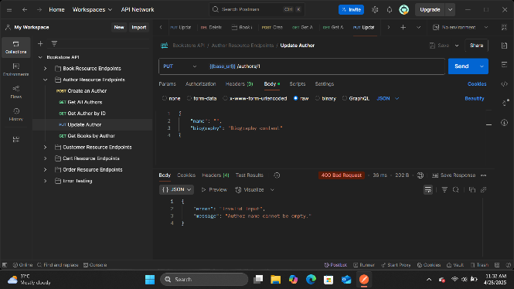
Figure 22 - Update author with empty name

2.2.5 DELETE /authors/{id} Endpoint:

Endpoint | Description | HTTP Method | Request Body (JSON) | Expected HTTP Status Code | Expected Response Body (JSON) | Actual Result
DELETE /authors/2 | Delete author by valid ID | DELETE | N/A | 204 No Content | N/A | Pass
DELETE /authors/999 | Delete author by invalid ID | DELETE | N/A | 404 Not Found | { "error": "Author Not Found", "message": "Author with ID 999 does not exist." } | Pass
DELETE /authors/1 | Delete author with books | DELETE | N/A | 400 Bad Request | { "error": "Invalid Input", "message": "Cannot delete author with books. Remove books first." } | Pass
Table 10 - DELETE /authors/{id} Endpoint
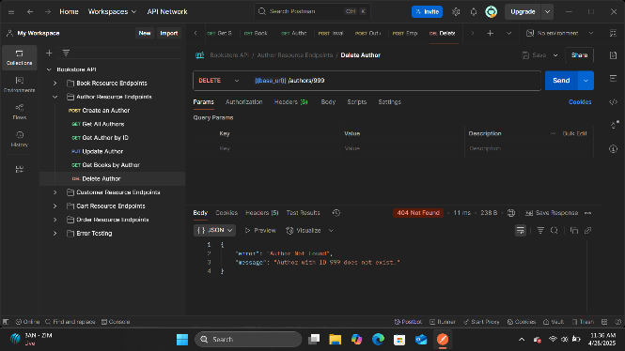
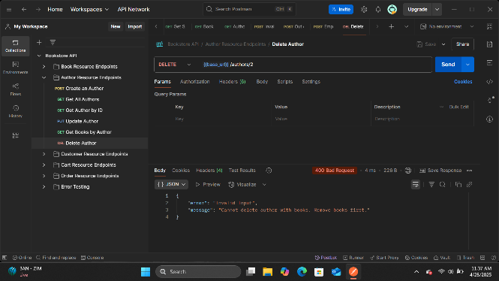
Figure 23 - Delete author by valid ID
Figure 24 - Delete author by invalid ID

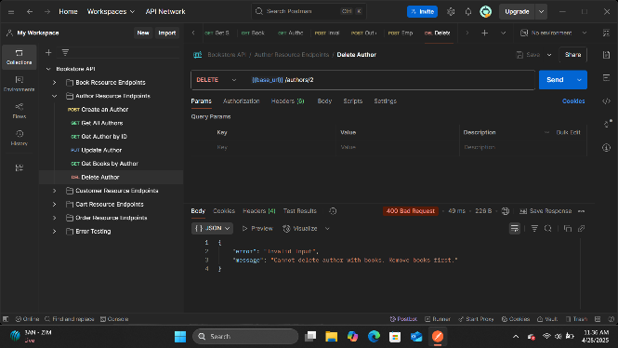
Figure 25 - Delete author with books

2.2.6 GET /authors/{id}/books Endpoint:

Endpoint | Description | HTTP Method | Request Body (JSON) | Expected HTTP Status Code | Expected Response Body (JSON) | Actual Result
GET /authors/1/books | Get books by author with valid ID | GET | N/A | 200 OK | [ { "id": 1, "title": "The Great Gatsby", ... }, { "id": 3, "title": "Tender Is the Night", ... } ] | Pass
GET /authors/999/books | Get books by author with invalid ID | GET | N/A | 404 Not Found | { "error": "Author Not Found", "message": "Author with ID 999 does not exist." } | Pass
GET /authors/2/books | Get books by author with no books | GET | N/A | 200 OK | [] | Pass
Table 11 - GET /authors/{id}/books Endpoint
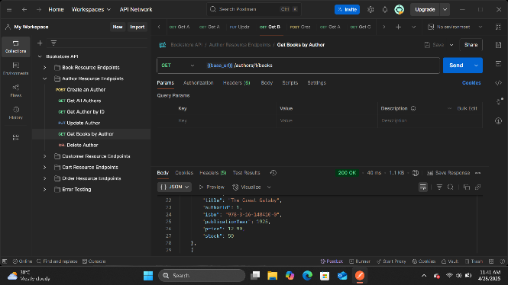
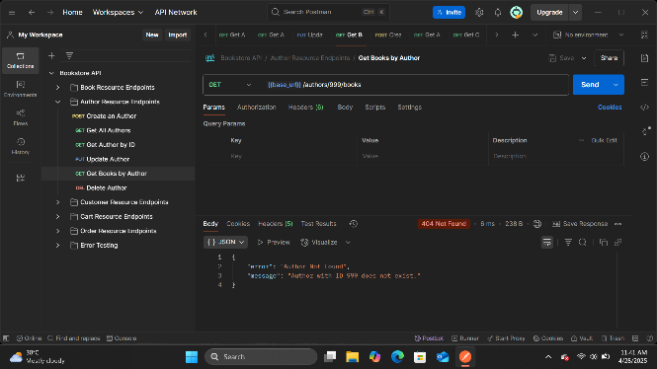
Figure 26 - Get books by author with valid ID
Figure 27 - Get books by author with invalid ID

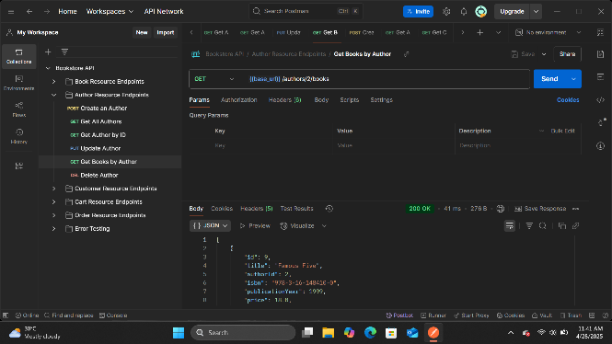
Figure 28 - Get books by author with no books

2.3 CustomerResource Test Cases

2.3.1 POST /customers Endpoint:

Endpoint | Description | HTTP Method | Request Body (JSON) | Expected HTTP Status Code | Expected Response Body (JSON) | Actual Result
POST /customers | Create a customer with valid data | POST | { "name": "John Doe", "email": "john@example.com", "password": "password123" } | 201 Created | { "id": 1, "name": "John Doe", "email": "john@example.com", "password": "password123" } | Pass
POST /customers | Create a customer with invalid email format | POST | { "name": "John Doe", "email": "not-an-email", "password": "password123" } | 400 Bad Request | { "error": "Invalid Input", "message": "Invalid email format." } | Pass
POST /customers | Create a customer with short password | POST | { "name": "John Doe", "email": "john@example.com", "password": "123" } | 400 Bad Request | { "error": "Invalid Input", "message": "Password must be at least 6 characters long." } | Pass
POST /customers | Create a customer with empty name | POST | { "name": "", "email": "john@example.com", "password": "password123" } | 400 Bad Request | { "error": "Invalid Input", "message": "Customer name cannot be empty." } | Pass
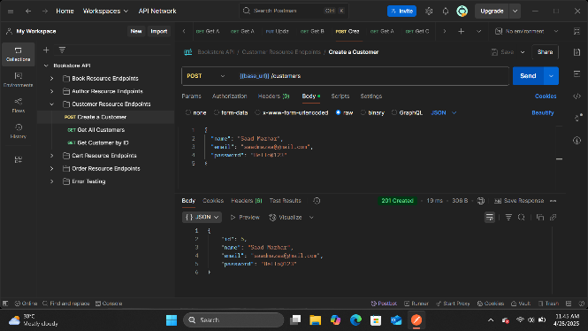
Table 12 - POST /customers Endpoint
Figure 29 - Create a customer with valid data
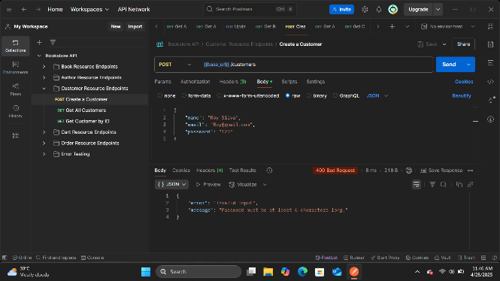
Figure 30 - Create a customer with invalid email format

2.3.2 GET /customers Endpoint:

Endpoint | Description | HTTP Method | Request Body (JSON) | Expected HTTP Status Code | Expected Response Body (JSON) | Actual Result
GET /customers | Get all customers | GET | N/A | 200 OK | [ { "id": 1, "name": "John Doe", "email": "john@example.com" }, { "id": 2, "name": "Jane Smith", "email": "jane@example.com" } ] | Pass
GET /customers | Get all customers (empty list) | GET | N/A | 200 OK | [] | Pass
Table 13 - GET /customers Endpoint
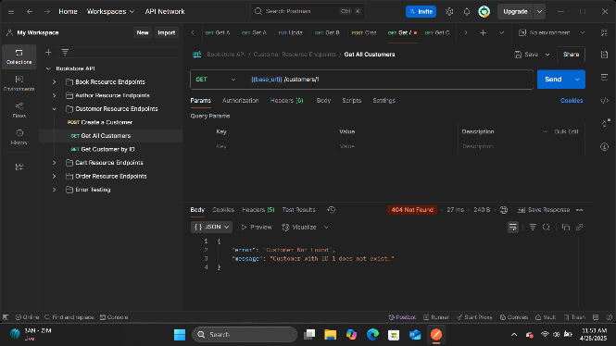
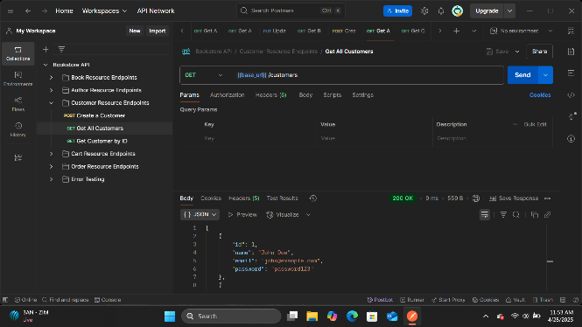
Figure 31 - Get all customers (empty list)
Figure 32 - Get all customers

2.3.3 GET /customers/{id} Endpoint:

Endpoint | Description | HTTP Method | Request Body (JSON) | Expected HTTP Status Code | Expected Response Body (JSON) | Actual Result
GET /customers/1 | Get customer by valid ID | GET | N/A | 200 OK | { "id": 1, "name": "John Doe", "email": "john@example.com" } | Pass
GET /customers/999 | Get customer by invalid ID | GET | N/A | 404 Not Found | { "error": "Customer Not Found", "message": "Customer with ID 999 does not exist." } | Pass
Table 14 - GET /customers/{id} Endpoint
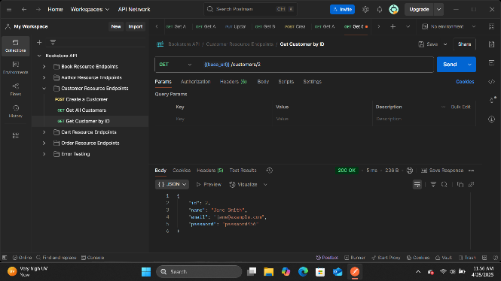
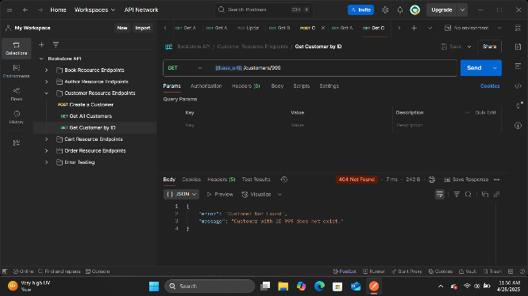
Figure 33 - Get customer by valid ID
Figure 34 - Get customer by invalid ID

2.3.4 PUT /customers/{id} Endpoint:

Endpoint | Description | HTTP Method | Request Body (JSON) | Expected HTTP Status Code | Expected Response Body (JSON) | Actual Result
PUT /customers/1 | Update customer with valid data | PUT | { "name": "John Doe Updated", "email": "john.updated@example.com", "password": "newpassword456" } | 200 OK | { "id": 1, "name": "John Doe Updated", "email": "john.updated@example.com", "password": "newpassword456" } | Pass
PUT /customers/999 | Update customer with non-existent ID | PUT | { "name": "Unknown Customer", "email": "unknown@example.com", "password": "password123" } | 404 Not Found | { "error": "Customer Not Found", "message": "Customer with ID 999 does not exist." } | Pass
PUT /customers/1 | Update customer with invalid email | PUT | { "name": "John Doe", "email": "invalid-email", "password": "password123" } | 400 Bad Request | { "error": "Invalid Input", "message": "Invalid email format." } | Pass
Table 15 - PUT /customers/{id} Endpoint
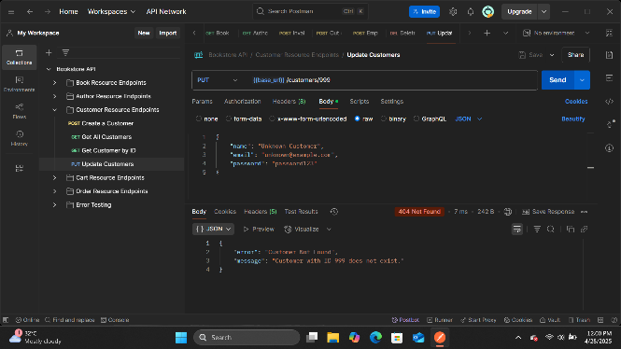
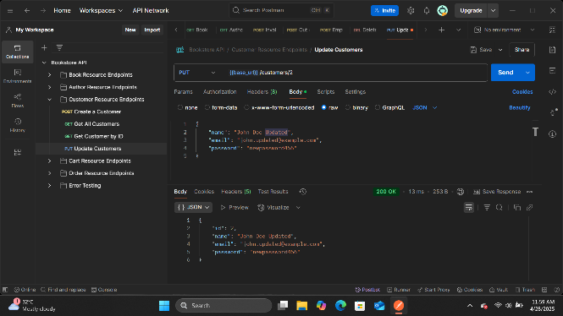
Figure 35 - Update customer with non-existent ID
Figure 36 - Update customer with valid data

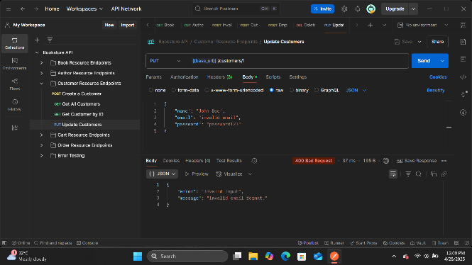
Figure 37 - Update customer with invalid email

2.3.5 DELETE /customers/{id} Endpoint:

Endpoint | Description | HTTP Method | Request Body (JSON) | Expected HTTP Status Code | Expected Response Body (JSON) | Actual Result
DELETE /customers/1 | Delete customer by valid ID | DELETE | N/A | 204 No Content | N/A | Pass
DELETE /customers/999 | Delete customer by invalid ID | DELETE | N/A | 404 Not Found | { "error": "Customer Not Found", "message": "Customer with ID 999 does not exist." } | Pass
Table 16 - DELETE /customers/{id} Endpoint
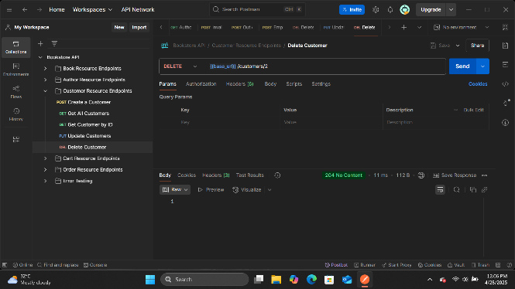
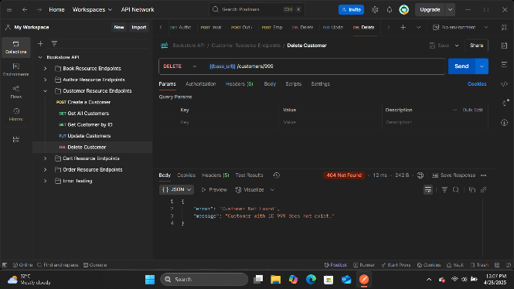
Figure 38 - Delete customer by valid ID
Figure 39 - Delete customer by invalid ID

2.4 CartResource Test Cases

2.4.1 GET /customers/{customerId}/cart Endpoint:

Endpoint | Description | HTTP Method | Request Body (JSON) | Expected HTTP Status Code | Expected Response Body (JSON) | Actual Result
GET /customers/1/cart | Get cart for customer with valid ID | GET | N/A | 200 OK | { "customerId": 1, "items": [ { "bookId": 1, "quantity": 2 }, { "bookId": 3, "quantity": 1 } ] } | Pass
GET /customers/999/cart | Get cart for customer with invalid ID | GET | N/A | 404 Not Found | { "error": "Customer Not Found", "message": "Customer with ID 999 does not exist." } | Pass
GET /customers/2/cart | Get empty cart for customer | GET | N/A | 200 OK | { "customerId": 2, "items": [] } | Pass
Table 17 - GET /customers/{customerId}/cart Endpoint
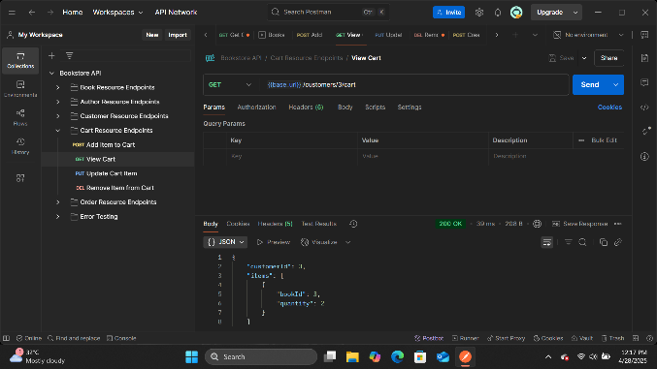
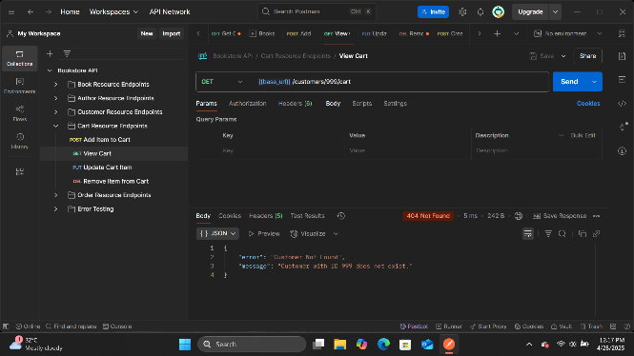
Figure 40 - Get cart for customer with valid ID
Figure 41 - Get cart for customer with invalid ID

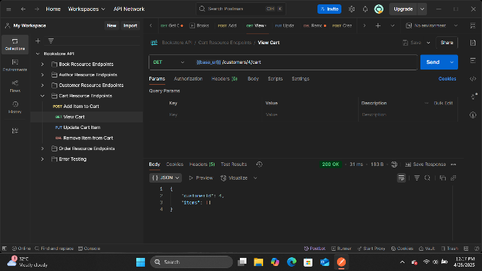
Figure 42 - Get empty cart for customer

2.4.2 POST /customers/{customerId}/cart/items Endpoint:

Endpoint | Description | HTTP Method | Request Body (JSON) | Expected HTTP Status Code | Expected Response Body (JSON) | Actual Result
POST /customers/1/cart/items | Add item to cart with valid data | POST | { "bookId": 1, "quantity": 2 } | 200 OK | { "customerId": 1, "items": [ { "bookId": 1, "quantity": 2 } ] } | Pass
POST /customers/999/cart/items | Add item to cart for customer with invalid ID | POST | { "bookId": 1, "quantity": 2 } | 404 Not Found | { "error": "Customer Not Found", "message": "Customer with ID 999 does not exist." } | Pass
POST /customers/1/cart/items | Add non-existent book to cart | POST | { "bookId": 999, "quantity": 2 } | 404 Not Found | { "error": "Book Not Found", "message": "Book with ID 999 does not exist." } | Pass
POST /customers/1/cart/items | Add item with negative quantity | POST | { "bookId": 1, "quantity": -1 } | 400 Bad Request | { "error": "Invalid Input", "message": "Quantity must be greater than zero." } | Pass
POST /customers/1/cart/items | Add item with quantity exceeding stock | POST | { "bookId": 1, "quantity": 1000 } | 400 Bad Request | { "error": "Out of Stock", "message": "Not enough stock. Available: 50" } | Pass
Table 18 - POST /customers/{customerId}/cart/items Endpoint

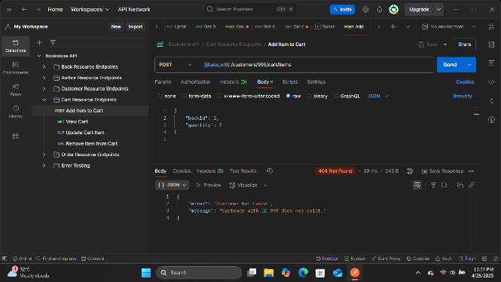
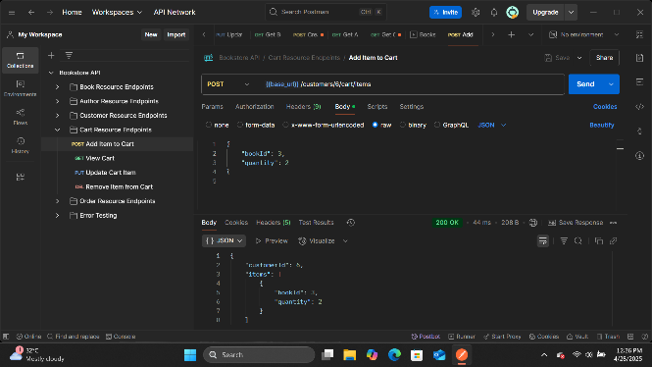
Figure 43 - Add item to cart for customer with invalid ID
Figure 44 - Add item to cart with valid data

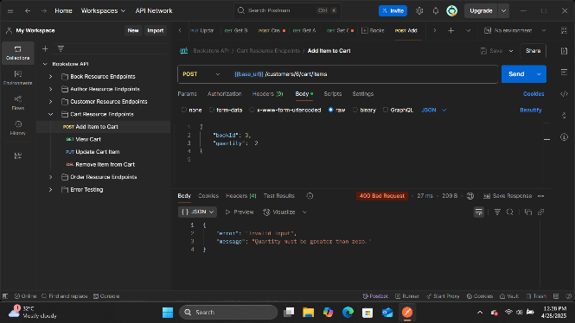
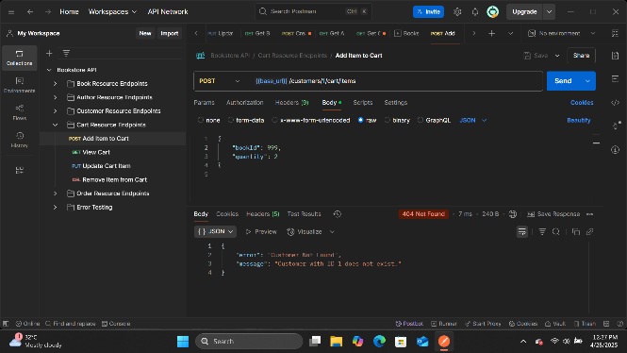
Figure 45 - Add item with negative quantity
Figure 46 - Add non-existent book to cart

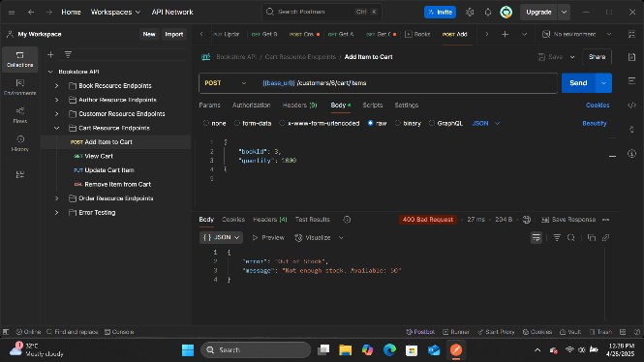
Figure 47 - Add item with quantity exceeding stock

2.4.3 PUT /customers/{customerId}/cart/items/{bookId} Endpoint:

Endpoint | Description | HTTP Method | Request Body (JSON) | Expected HTTP Status Code | Expected Response Body (JSON) | Actual Result
PUT /customers/1/cart/items/1 | Update cart item with valid data | PUT | { "quantity": 3 } | 200 OK | { "customerId": 1, "items": [ { "bookId": 1, "quantity": 3 } ] } | Pass
PUT /customers/999/cart/items/1 | Update cart item for customer with invalid ID | PUT | { "quantity": 3 } | 404 Not Found | { "error": "Customer Not Found", "message": "Customer with ID 999 does not exist." } | Pass
PUT /customers/1/cart/items/999 | Update non-existent cart item | PUT | { "quantity": 3 } | 404 Not Found | { "error": "Cart Not Found", "message": "Book with ID 999 not found in cart." } | Pass
PUT /customers/1/cart/items/1 | Update cart item with negative quantity | PUT | { "quantity": -1 } | 400 Bad Request | { "error": "Invalid Input", "message": "Quantity must be greater than zero." } | Pass
PUT /customers/1/cart/items/1 | Update cart item with quantity exceeding stock | PUT | { "quantity": 1000 } | 400 Bad Request | { "error": "Out of Stock", "message": "Not enough stock. Available: 50" } | Pass
Table 19 - PUT /customers/{customerId}/cart/items/{bookId} Endpoint
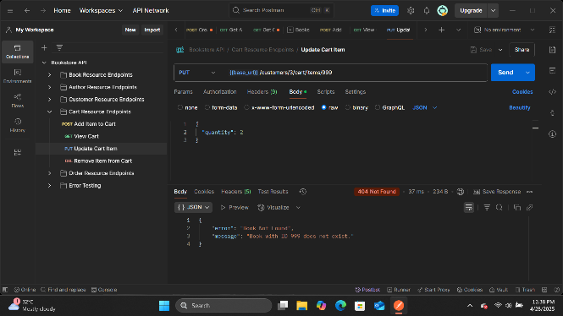
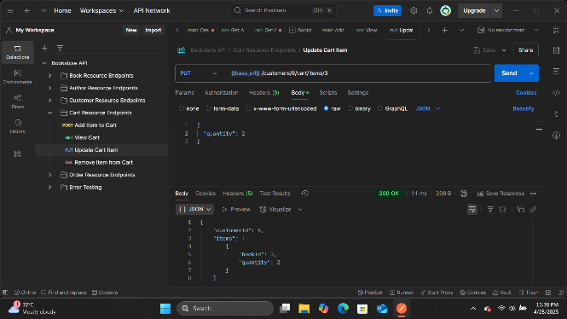
Figure 48 - Update cart item for customer with invalid ID
Figure 49 - Update cart item with valid data

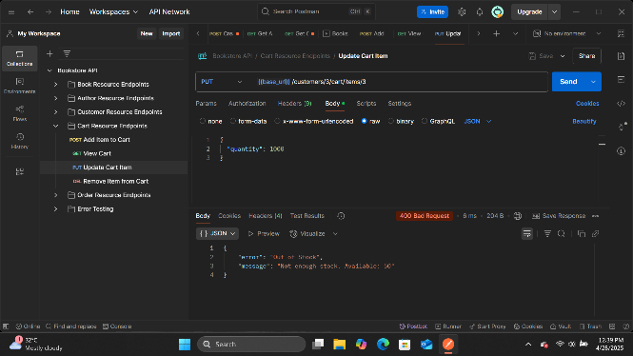
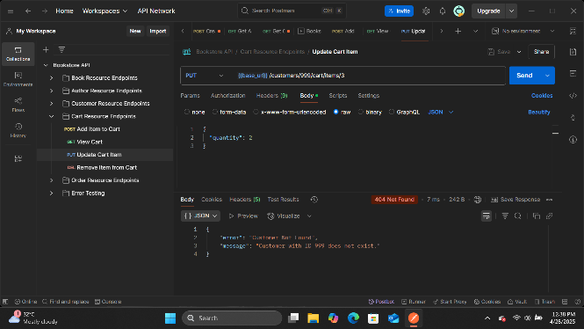
Figure 50 - Update cart item with negative quantity
Figure 51 - Update non-existent cart item

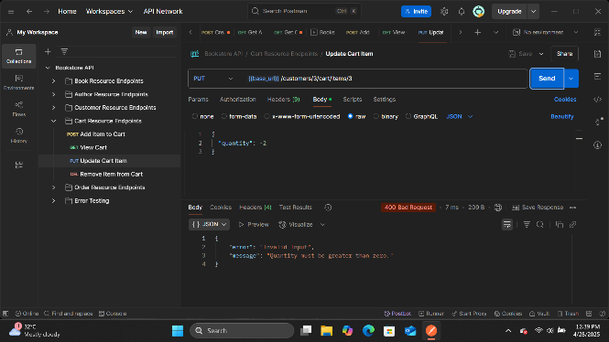
Figure 52 - Update cart item with quantity exceeding stock

2.4.4 DELETE /customers/{customerId}/cart/items/{bookId} Endpoint:

Endpoint | Description | HTTP Method | Request Body (JSON) | Expected HTTP Status Code | Expected Response Body (JSON) | Actual Result
DELETE /customers/1/cart/items/1 | Remove item from cart with valid IDs | DELETE | N/A | 200 OK | { "customerId": 1, "items": [] } | Pass
DELETE /customers/999/cart/items/1 | Remove item from cart for customer with invalid ID | DELETE | N/A | 404 Not Found | { "error": "Customer Not Found", "message": "Customer with ID 999 does not exist." } | Pass
DELETE /customers/1/cart/items/999 | Remove non-existent cart item | DELETE | N/A | 404 Not Found | { "error": "Cart Not Found", "message": "Book with ID 999 not found in cart." } | Pass
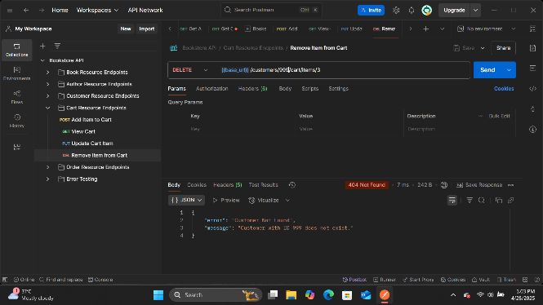
Table 20 - DELETE /customers/{customerId}/cart/items/{bookId} Endpoint
Figure 53 - Remove item from cart for customer with invalid ID
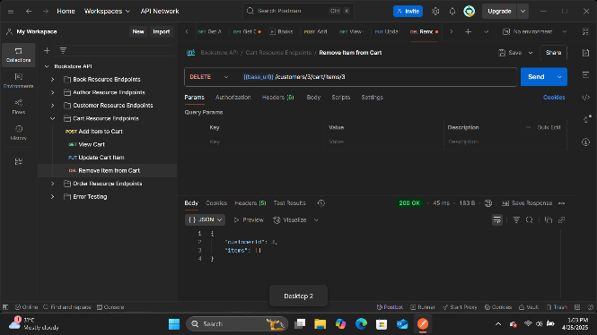
Figure 54 - Remove item from cart with valid IDs

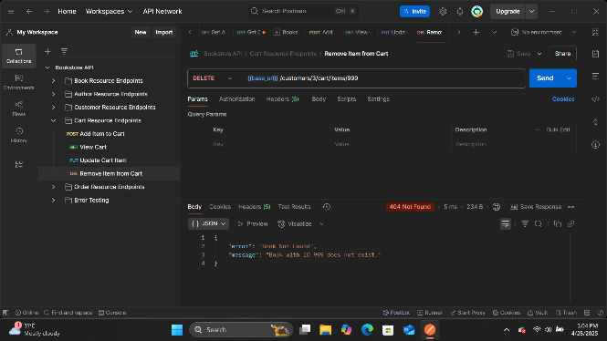
Figure 55 - Remove non-existent cart item

2.5 OrderResource Test Cases

2.5.1 POST /customers/{customerId}/orders Endpoint:

Endpoint | Description | HTTP Method | Request Body (JSON) | Expected HTTP Status Code | Expected Response Body (JSON) | Actual Result
POST /customers/1/orders | Create order with items in cart | POST | N/A | 201 Created | { "id": 1, "customerId": 1, "orderDate": "2025-04-27T12:00:00", "totalAmount": 25.98, "items": [ { "bookId": 1, "quantity": 2, "price": 12.99 } ] } | Pass
POST /customers/999/orders | Create order for customer with invalid ID | POST | N/A | 404 Not Found | { "error": "Customer Not Found", "message": "Customer with ID 999 does not exist." } | Pass
POST /customers/2/orders | Create order with empty cart | POST | N/A | 400 Bad Request | { "error": "Invalid Input", "message": "Cannot create order with empty cart." } | Pass
POST /customers/1/orders | Create order with item exceeding stock | POST | N/A | 400 Bad Request | { "error": "Out of Stock", "message": "Not enough stock for book: The Great Gatsby. Available: 5" } | Pass
Table 21 - POST /customers/{customerId}/orders Endpoint

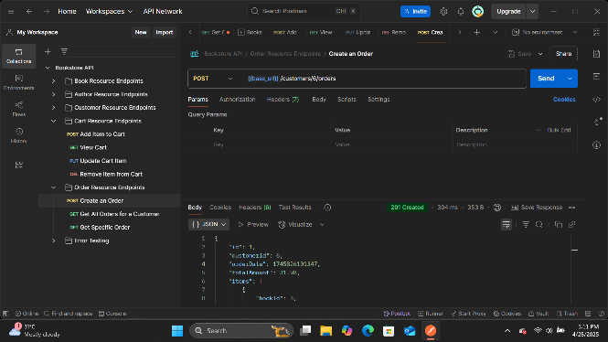
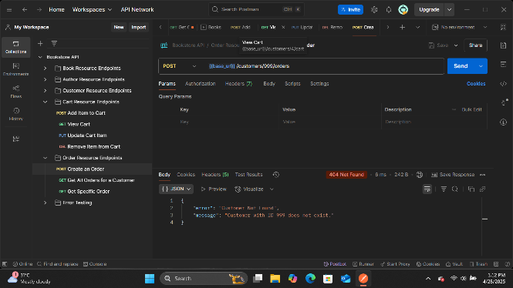
Figure 56 - Create order with items in cart
Figure 57 - Create order for customer with invalid ID

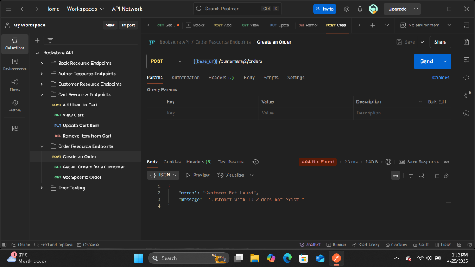
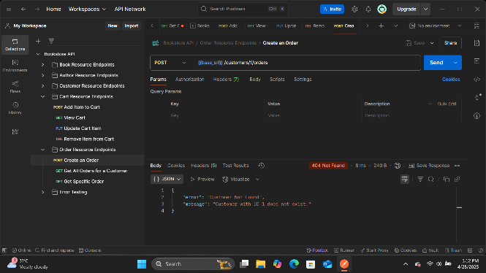
Figure 58 - Create order with item exceeding stock
Figure 59 - Create order with empty cart

2.5.2 GET /customers/{customerId}/orders Endpoint:

Endpoint | Description | HTTP Method | Request Body (JSON) | Expected HTTP Status Code | Expected Response Body (JSON) | Actual Result
GET /customers/1/orders | Get orders for customer with valid ID | GET | N/A | 200 OK | [ { "id": 1, "customerId": 1, "orderDate": "2025-04-27T12:00:00", "totalAmount": 25.98, "items": [ { "bookId": 1, "quantity": 2, "price": 12.99 } ] } ] | Pass
GET /customers/999/orders | Get orders for customer with invalid ID | GET | N/A | 404 Not Found | { "error": "Customer Not Found", "message": "Customer with ID 999 does not exist." } | Pass
GET /customers/2/orders | Get orders for customer with no orders | GET | N/A | 200 OK | [] | Pass
Table 22 - GET /customers/{customerId}/orders Endpoint
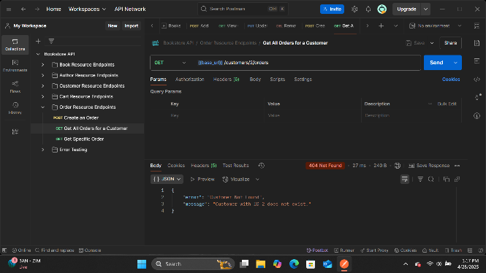
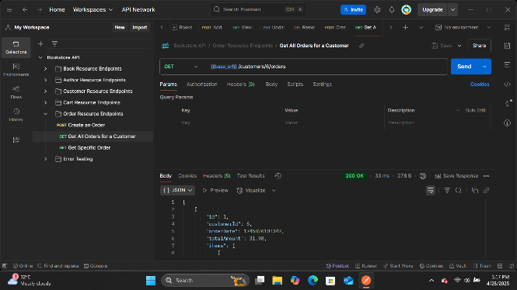
Figure 60 - Get orders for customer with invalid ID
Figure 61 - Get orders for customer with valid ID

2.5.3 GET /customers/{customerId}/orders/{orderId} Endpoint:

Endpoint | Description | HTTP Method | Request Body (JSON) | Expected HTTP Status Code | Expected Response Body (JSON) | Actual Result
GET /customers/1/orders/1 | Get order with valid customer and order IDs | GET | N/A | 200 OK | { "id": 1, "customerId": 1, "orderDate": "2025-04-27T12:00:00", "totalAmount": 25.98, "items": [ { "bookId": 1, "quantity": 2, "price": 12.99 } ] } | Pass
GET /customers/999/orders/1 | Get order for customer with invalid ID | GET | N/A | 404 Not Found | { "error": "Customer Not Found", "message": "Customer with ID 999 does not exist." } | Pass
GET /customers/1/orders/999 | Get non-existent order | GET | N/A | 404 Not Found | { "error": "Customer Not Found", "message": "Order with ID 999 not found for customer 1" } | Pass
Table 23 - GET /customers/{customerId}/orders/{orderId} Endpoint
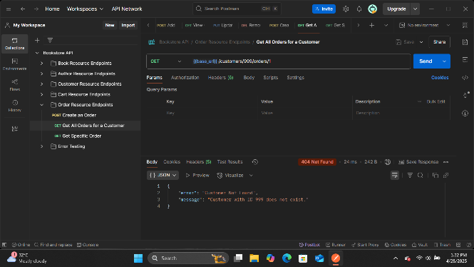
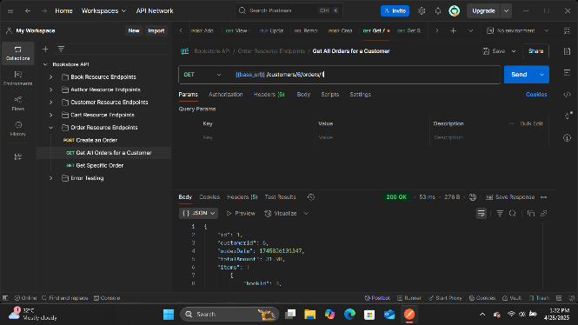
Figure 62 - Get order for customer with invalid ID
Figure 63 - Get order with valid customer and order IDs

